Project and Client Details
Project Name - Number | The Sands, Torquay - Management of Lakes & Waterways - M001368
Date: | 29 Jun 2020
Crew: | Liam McGarry  Kirsty McNamara  Aaron Collura
Site Condition: | Vegetation along the wetland is improving, weeds are under control and growth and regeneration is seen in native vegetation. The repaired weirs in the water way have seen a slow in water flow, this has resulted in blue green algae in areas. Where weirs have been repaired there is removed vegetation and tyre tracks. The site is very clean, there was no visible rubbish, vandalism or vandalism.
Weed Cover: | Weed cover in the site is very low. The water cooch along the edges to the western end of the site have been successfully controlled and the majority of it has died off. The typha that was present in the water ways has been successfully removed and controlled.  Weeds in the garden beds are low, the majority were broadleaf weeds or cooch grass that was growing from the golf course. A herbicide run was done on the site to control the control these weeds. The success of spraying rings around native vegetation to allow the to grow was expanded so that they can hopefully seed. The large dead bone seed were removed from the site. And serrated tussock has nearly been eradicated from the scope of our works.
Plant Health: | The plant health along the site has seen and improvement. Areas within our scope has weed grass species out competing native grasses, a ring was sprayed around these native grasses to allow them to grow and since last visit they have grown in size. These rings will slowly be expanded as the grasses get larger and more grow from seed. They are slowly expanded so that erosion does not occur along the banks.
Infill Required: | Infill around the weirs that have been upgraded is required a mix of aquatic native plants, grasses and small shrubs would be ideal
Mature Trees: | Mature trees are healthy along the water way and need no extra attention.
Turf: | There is no turf in our scope.
Street Furniture: | There in no street furniture in our scope.
Paths: | The paths that were adjacent to the site had no overhanging vegetation.
Works Undertaken: | Herbicide run of the entire site.  Removal of remaking typha and dead bone seed.
Future Works Required: | Infill planting of weirs and continued weed management along site.

Site Photos
Site Photos:
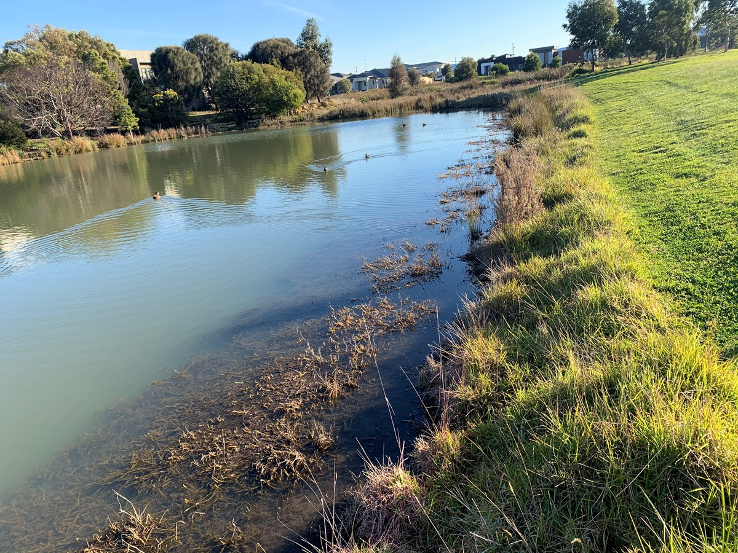
Photo Comments: | Controlled water cooch

Site Photos:
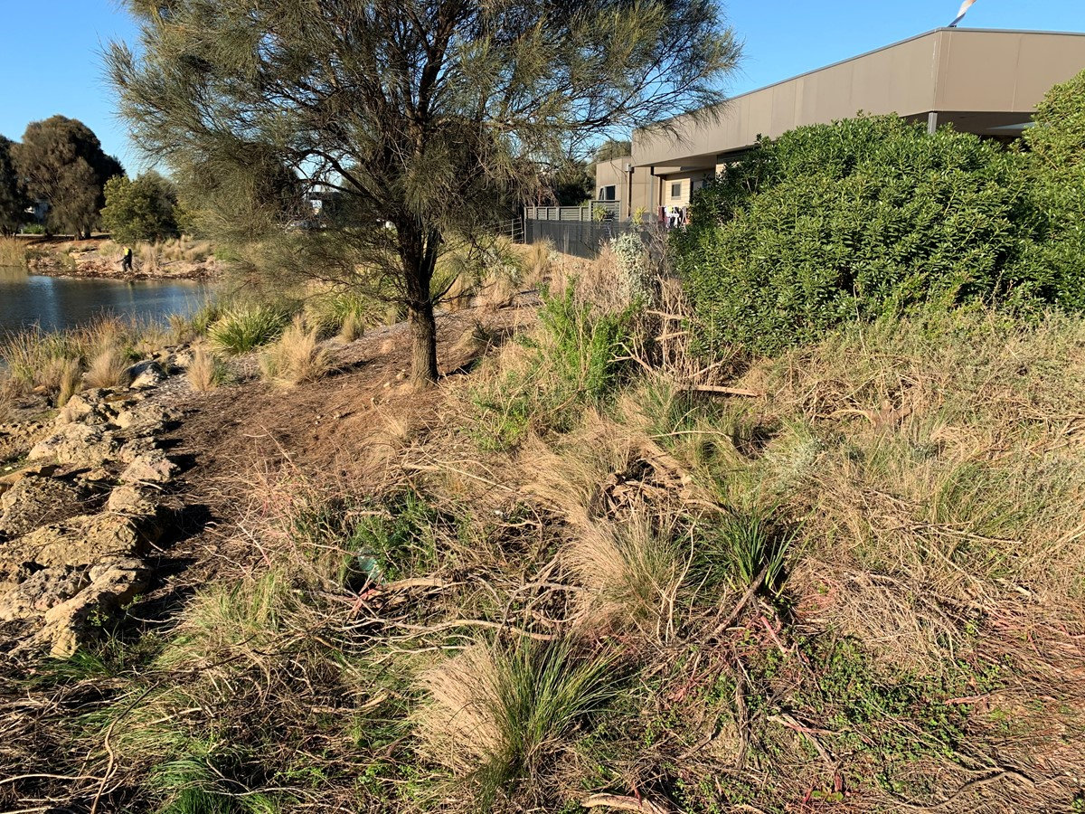
Photo Comments: | Removed bone seed

Site Photos:
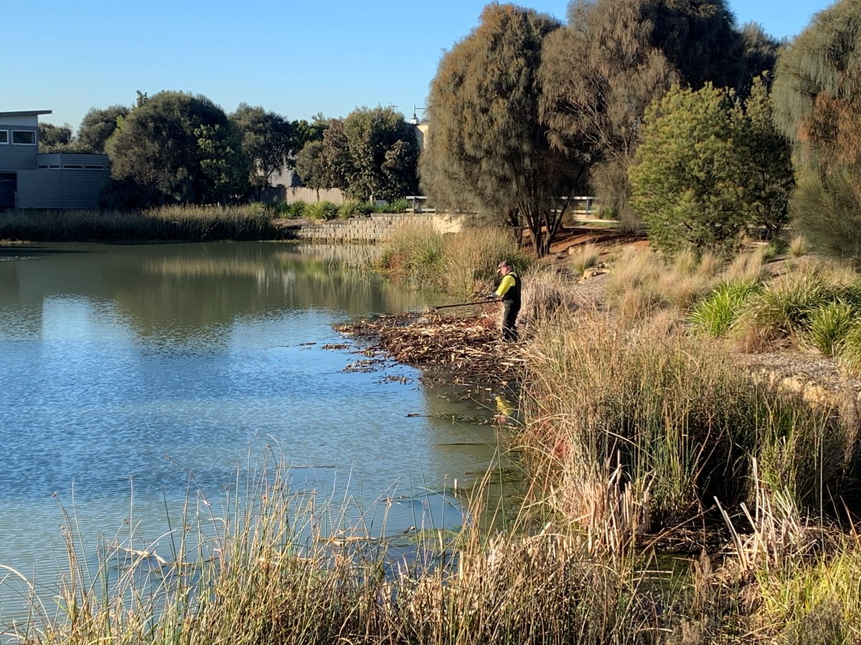
Photo Comments: | Removal of remaining typha

Chemical Usage Details
Maintenance or Prep: | Maintenance
Application Method: | Knapsack
Target Weeds: | Kikuyu, cooch grass, sonchous, serrated tussock, brassica and Bose seed
Rate: | per 10L
Chemical 1: Active Ingredient: MOA Group: | WEEDMASTER DUO-360 g/L GLYPHOSATE present as the ISOPROPYLAMINE and MONO-AMMONIUM SALTS
Chemical 1 Rate: (mls/gms) | 100
Chemical 2: Active Ingredient: MOA Group: | AGRITONE 750-750 g/L MCPA present as the dimethylamine salt
Chemical 2 Rate: (mls/gms) | 20
Surfactant/Penetrant | BS 1000-1020 g/l ALCOHOL ALKOXYLATE
Surfactant/Penetrant Rate: (mls/gms) | 10
Dye Type: | ENVIRODYE RED-Diazo Dye
Dye Rate(ml): | 40
Spray Volume(Ltrs) | 95
Batches Mixed | 9.5
Total Chem 1: Qty (ml) | 950
Total Chem 2: Qty (ml) | 190
Total Surfactant/Penetrant: Qty (ml) | 95
Total Dye Qty (ml): | 380

Weather
Sky | 'clear'
Temperature (degrees) | 14
Wind speed(kph) | 8
Wind direction | South East
I certify that this is a true and accurate record of agricultural spraying.
Name of Person completing Spray Record: | Liam McGarry
Date: | 29 Jun 2020

