Project and Client Details
Project Name - Number | The Sands, Torquay - Management of Lakes & Waterways - M001368
Date: | 10 Aug 2020
Crew: | Liam McGarry  Aaron Collura  Aaron Taylor  Kirsty McNamara
Site Condition: | The site has no damage, no visible erosion and no vandalism. Vegetation has come loose in the water way and is banked up at the bottom weir. Overall site is healthy with nothing out of the ordinary to report on.
Weed Cover: | Weed cover is low across the site and is at a manageable level.
Plant Health: | Areas around the weirs have had construction done to them and so no vegetation was left, plants were installed around these areas to replace the vegetation that was damaged or removed.
Infill Required: | 1000 plants were infilled on the day with another 1000 to come.
Mature Trees: | Na
Turf: | Na
Street Furniture: | NA
Paths: | No vegetation was overhanging on the paths.
Works Undertaken: | Installation of 1000 plants.
Future Works Required: | Install the remanding plants

Site Photos
Site Photos:
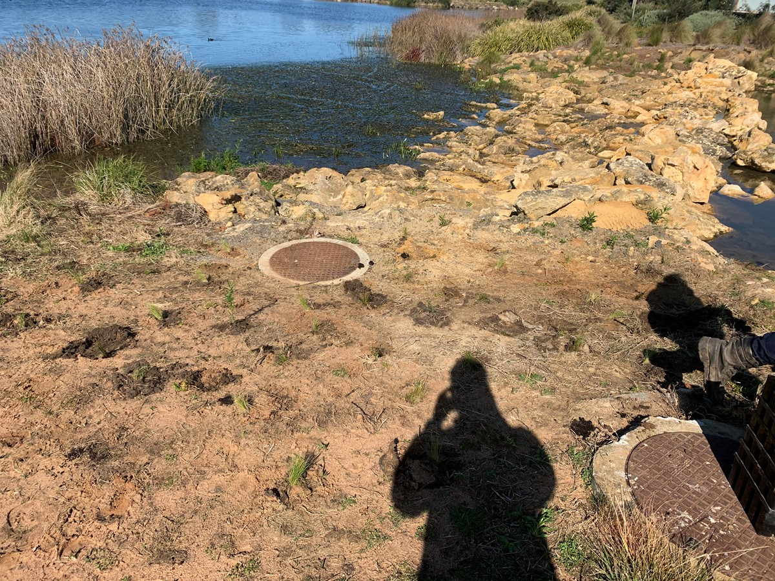
Photo Comments:

Site Photos:
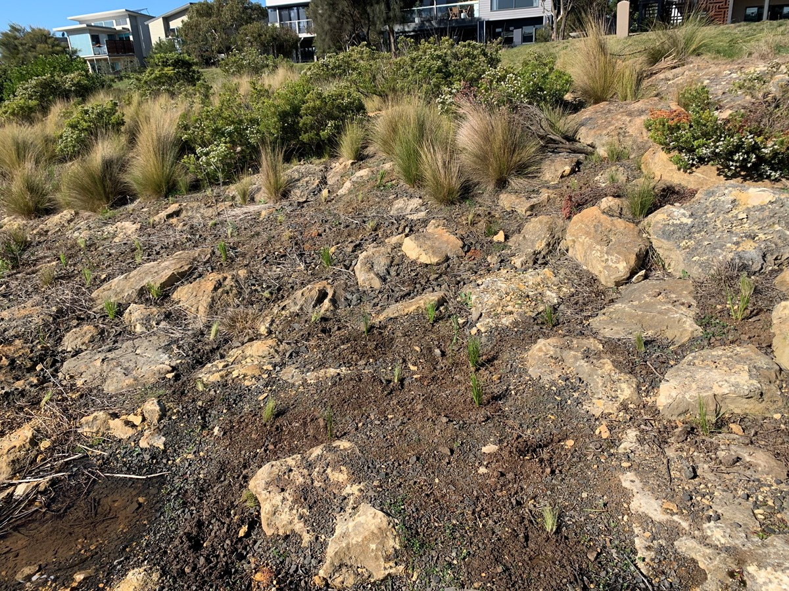
Photo Comments:

Site Photos:
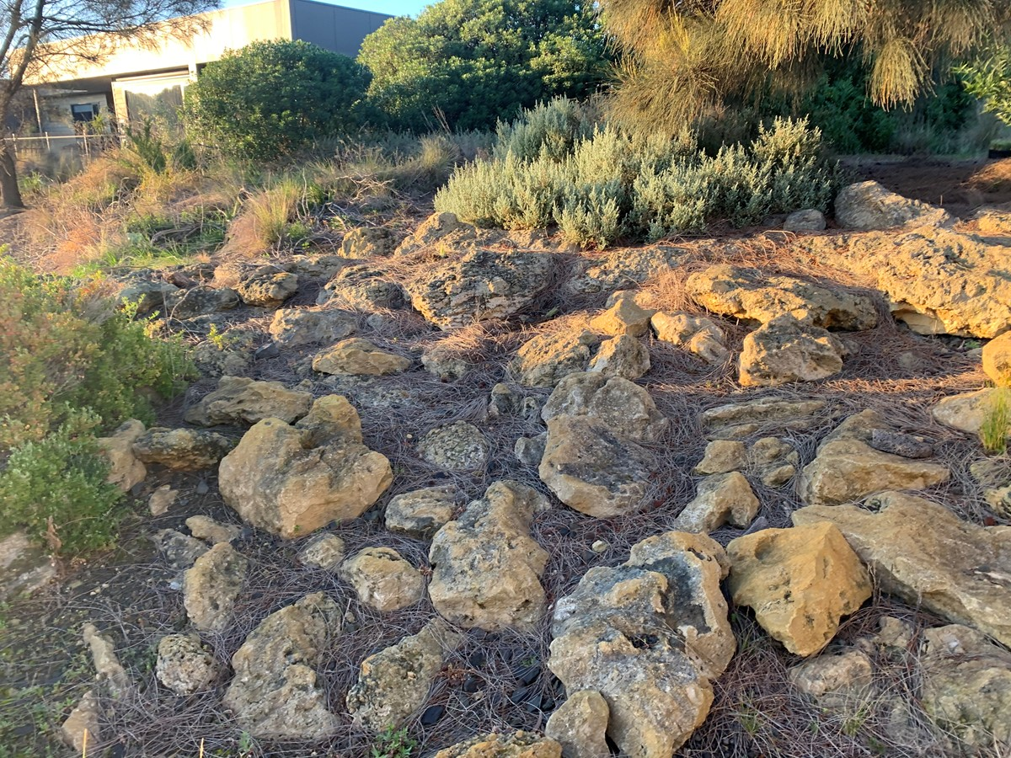
Photo Comments:

Weather
Sky | 'clear'
Temperature (degrees) | 18
Wind speed(kph) | 10
Wind direction | East
I certify that this is a true and accurate record of agricultural spraying.
Name of Person completing Spray Record: | Liam McGarry
Date: | 10 Aug 2020

